**John Jimenez**

# **Group 8:** Info Arch Innovators **Assignment 4**: Wireframe Based Prototype **Org:** Tri-County Humane Society **URL:** https://tricountyhumanesociety.org **Date:** March 28 2024

**Purpose of the Site:**

The Tri-County Humane Society website is designed to facilitate and encourage community engagement through volunteer opportunities and pet adoptions. This site serves as a hub for animal lovers to connect with the society and contribute to the welfare of animals through various activities.

**Primary Target Users:**

The website's primary users are potential and existing volunteers who wish to dedicate their time and resources to animal care and society operations.

**Main Changes/Improvements:**

Notable improvements to the site's Information Architecture include a streamlined navigation system, prominent calls to action for volunteer engagement, and an intuitive user journey for individuals looking to volunteer.

**Main Target User Group Assigned:**

My assigned user group is volunteers — people driven by compassion, seeking opportunities to support animal welfare.

**Description of the Persona:**

The persona that represents this group is 'John', an active community member and animal enthusiast looking to contribute to animal welfare through volunteering.

**Main Task Supported by Prototype:**

John's primary tasks include discovering volunteer roles, signing up for events, and managing his volunteer activities through a user-friendly interface.

**[Wireframes Annotations]**

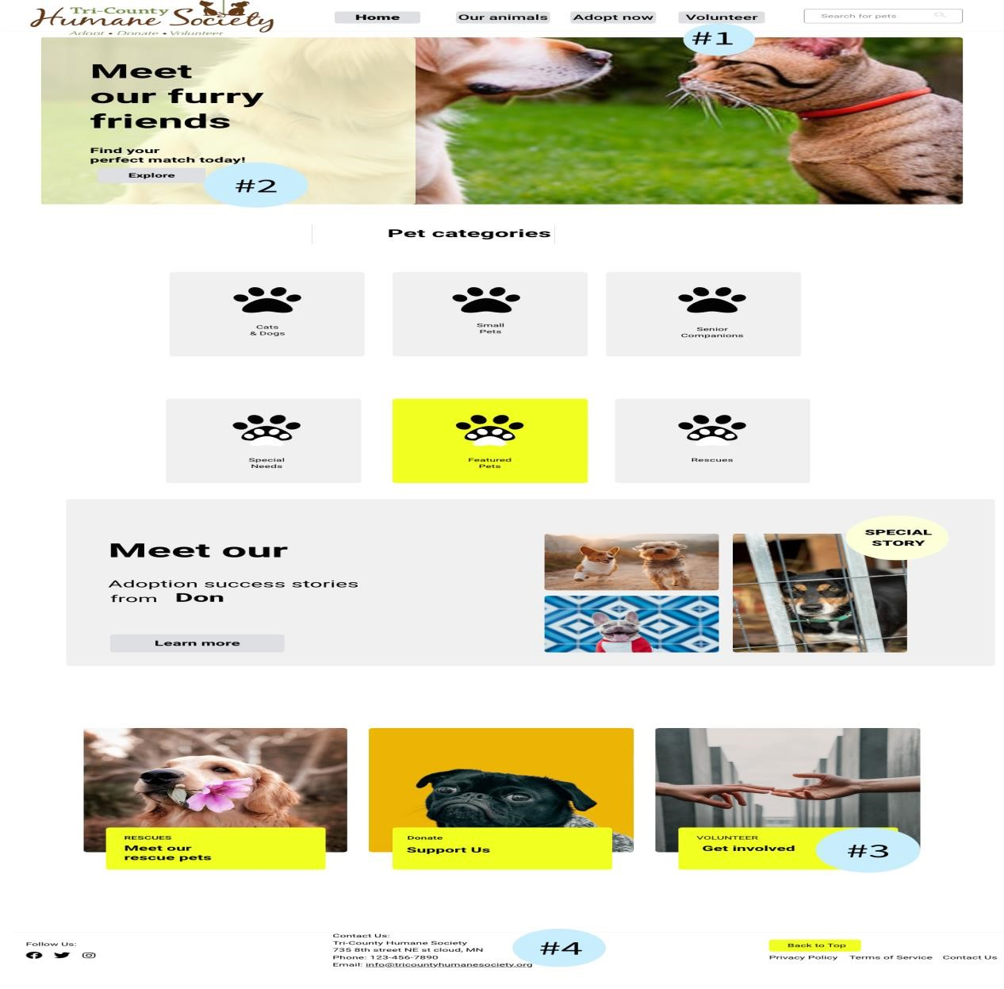

**Home Page annotations**

1. Main Navigation: A clear and accessible navigation bar providing a path to the key areas of the site.
2. Hero Section: A large, engaging image with a call to action that draws users to explore pet adoption options.
3. Get Involved Button: Positioned to attract users interested in volunteering.
4. Footer: Includes essential contact details and social media links for further engagement.

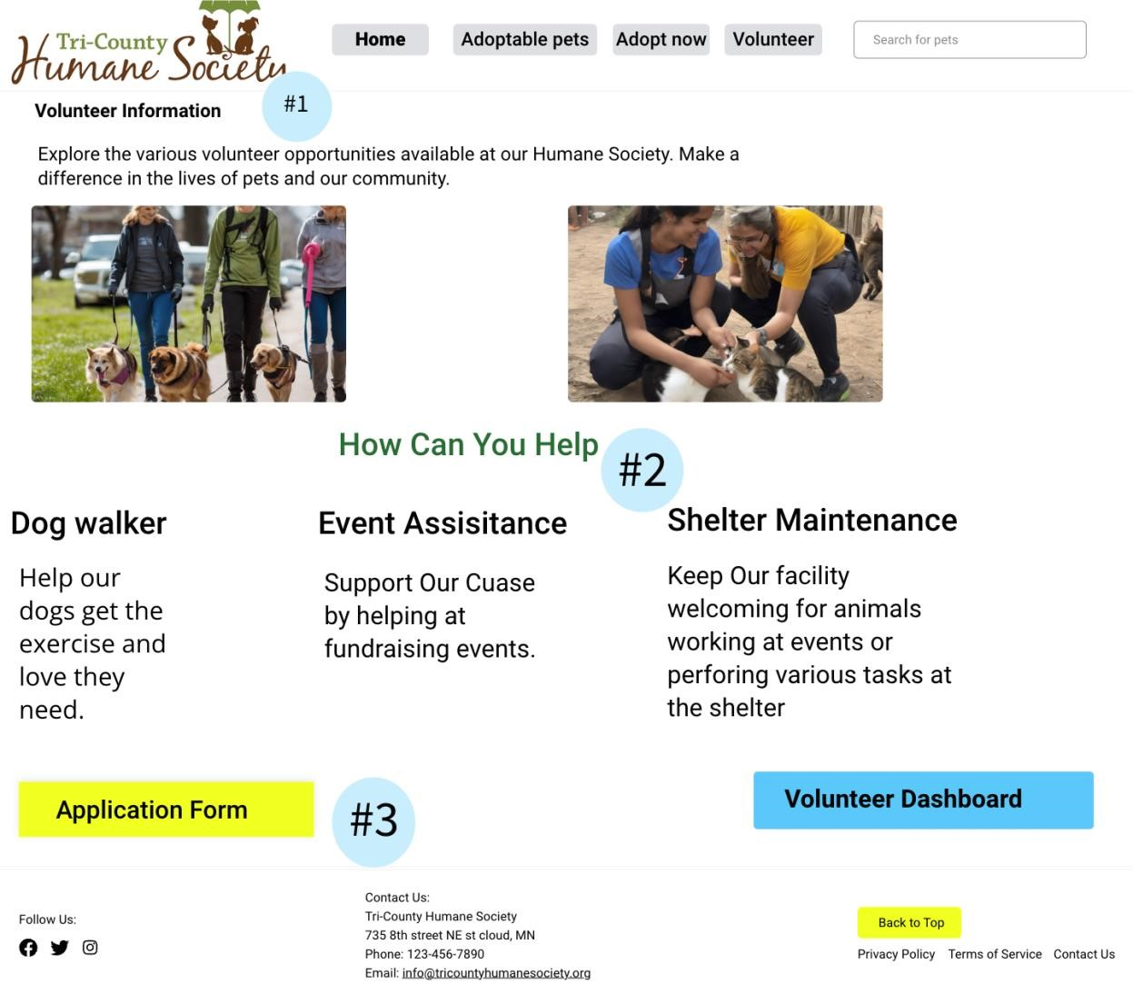

**Volunteer information page annotations**

1. Information Header: Introduces the volunteering section and outlines the opportunities available.
2. How You Can Help: Describes different roles and tasks a volunteer can undertake.
3. Application Form: Allows users to go to the application site to apply to be a volunteer

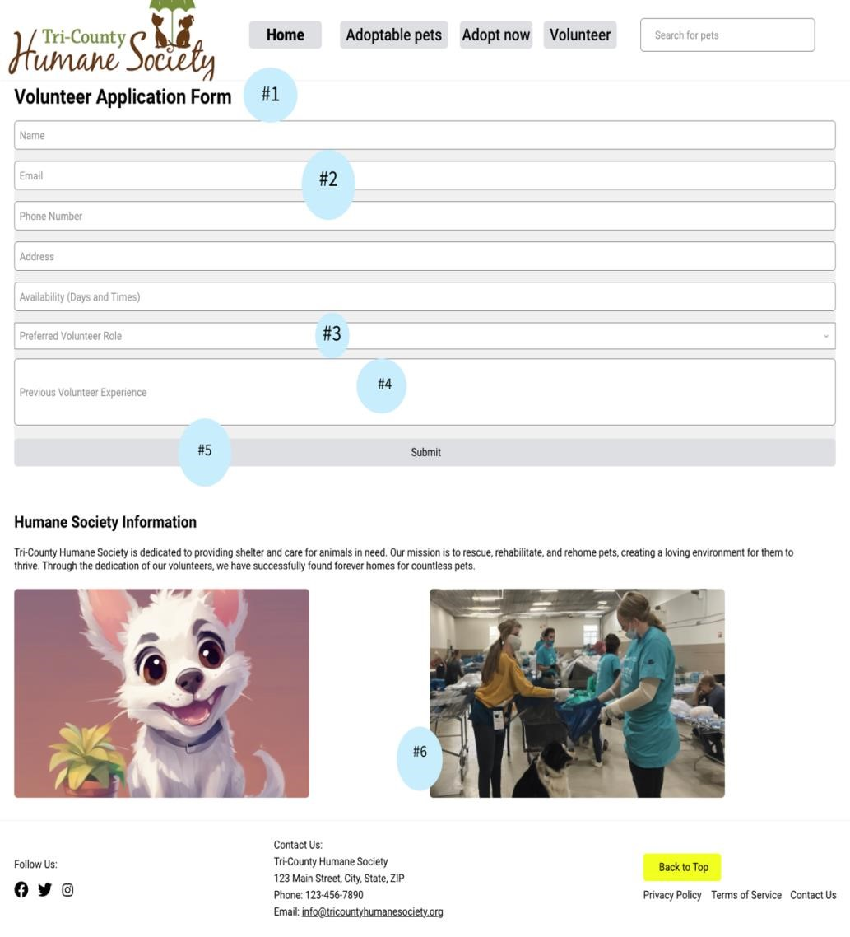

**Volunteer application annotations.**

1. Form Header: Indicates the purpose of the page – a form for new volunteer applications.
2. Email Field: An essential field for capturing volunteer contact information. 3.) Preferred Volunteer Role: Allows users to select the role that best suits their interests.
3. Previous Volunteer Experience: Captures information about the volunteer’s past engagements.
4. Submit Button: Completes and submits the application process.
5. Mission Statement: Conveys the core objectives of the humane society.

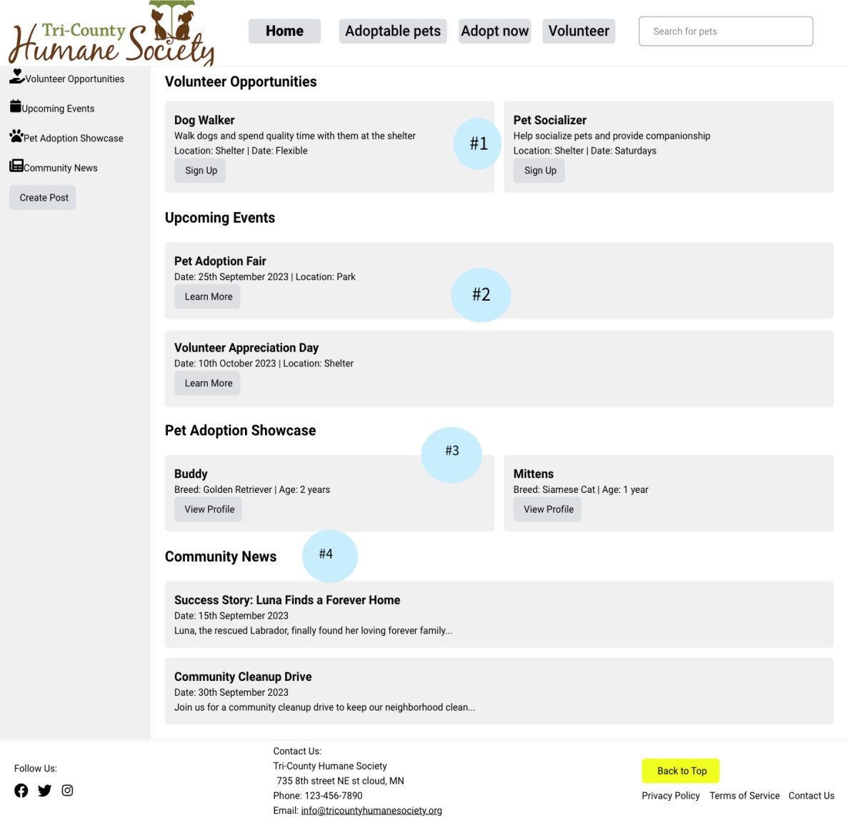

**Volunteer dashboard annotations**

1. Sign Up for Volunteer Opportunities (Annotation #1): Quick sign-up links for current volunteering events and activities.
2. Calendar of Events (Annotation #2): A calendar feature that provides volunteers with information about upcoming events and opportunities to get involved."
3. Pet Adoption Showcase (Annotation #3): "A section that highlights pets currently available for adoption, potentially as a part of the volunteer advocacy program.
4. Community News Section (Annotation #4): Latest updates and stories from the shelter, keeping volunteers informed and engaged with the humane society’s success and needs.